https://support.nagios.com/forum/viewtopic.php?f=7&t=38779&p=185712#p185712

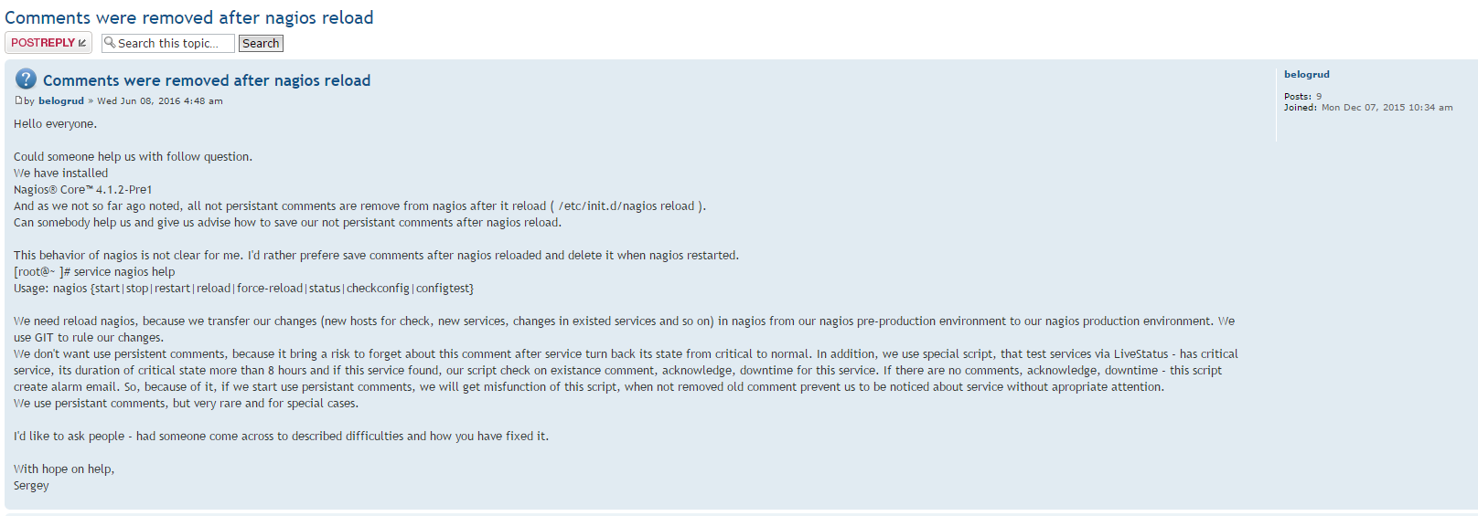

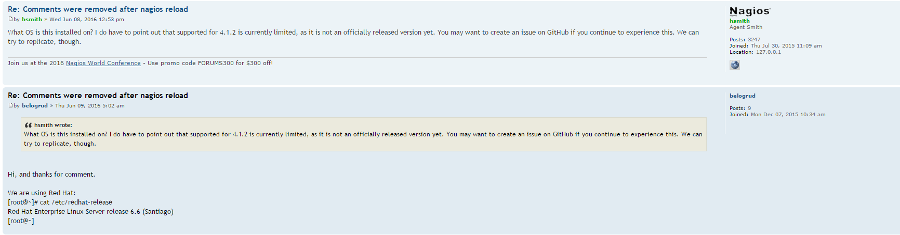

Hi lmiltchev.

Thank you very much.
Thanks everyone who took a part in this conversation.

I'll wait results of testing task.

20161107
https://support.nagios.com/forum/ucp.php?i=pm&mode=view&p=5826

Where to find info about internal feature request ID8830

Hello Sir.

Several months ago you have written follow:
"...I created an internal feature request (ID 8830) to have non-persistent comments be maintained through a Nagios reload. ...".
It was here:
https://support.nagios.com/forum/viewtopic.php?f=7&t=38779&start=10

Could you advise me please, where can I see status of created request ID 8830?

This request was created during communicationg with me about follow question:
"Comments were removed after nagios reload"
https://support.nagios.com/forum/viewtopic.php?f=7&t=38779&sid=6d025c7e34f98bc1045c1fd968c5356e&start=10

I'd like to know - is this issue solved or not yet?
If it already fixed - since what nagios release it was done?
If everything is OK - I could turn of my scripts, that time to time save comments and restore it again.

I've tried to find ID number 8830 here:
http://tracker.nagios.org/
But it was unsuccessful. Google not advice me where to find "internal feature request" for nagios.
That's why I ask your help.

With best regards,
Sergey Belogrud.

From: Belogrud Sergey Vladimirovich
Sent: Monday, November 07, 2016 8:21 PM
To: Leonov Aleksey Vladimirovich
Subject: RE: Дублирование процессов скриптов, запущенных по cron

Вот что ответили на форуме support.nagios.com.

Re: Where to find info about internal feature request ID8830
Sent: Mon Nov 07, 2016 6:03 pm
From: mcapra
To: belogrud
There isn't currently a very good way by which users can track feature requests and bug fixes. This is something we plan to correct in the future.

This appears to have been included in Nagios Core 4.2.2:
https://github.com/NagiosEnterprises/na ... fe1644e25a

Where to find info about internal feature request ID8830
Sent: Mon Nov 07, 2016 12:51 pm
by belogrud
Hello Sir.

Several months ago you have written follow:
"...I created an internal feature request (ID 8830) to have non-persistent comments be maintained through a Nagios reload. ...".
It was here:
viewtopic.php?f=7&t=38779&start=10

Could you advise me please, where can I see status of created request ID 8830?

This request was created during communicationg with me about follow question:
"Comments were removed after nagios reload"
viewtopic.php?f=7&t=38779&start=10

I'd like to know - is this issue solved or not yet?
If it already fixed - since what nagios release it was done?
If everything is OK - I could turn of my scripts, that time to time save comments and restore it again.

I've tried to find ID number 8830 here:
http://tracker.nagios.org/
But it was unsuccessful. Google not advice me where to find "internal feature request" for nagios.
That's why I ask your help.

With best regards,
Sergey Belogrud.

